**RESUME** 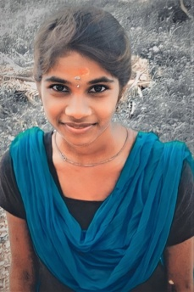

**KISARTHTHINI.M**

Contact No : **9080605859**

Mail Id : [kishamuthu092004@gmaail.com](mailto:kishamuthu092004@gmaail.com)

**CAREER OBJECTIVE**

I Am looking for an opportunity to use my skills and abilities to make a positive impact on

An IT organization. I Am a team player who is able to work effectively in a fast paced

Environment. I am commited to continuous learning and willing to take on new challenges.

**EDUCATIONAL DETAILS**

|  |  |  |  |  |
| --- | --- | --- | --- | --- |
| **COURSE** | **SCHOOL/COLLEGE** | **BOARD/UNIVERSITY** | **YEAR OF PASSING** | **PERCENTAGE** |
| SSLC | GOVT MODEL GIRLS HR SEC SCHOOL,MANNCHANALLUR. | STATE BOARD | 2018 | 71% |
| HSS | GOVT MODEL GIRLS HR SEC SCHOOL,MANNACHANALLUR. | STATE BOARD | 2020 | 80% |
| BCA | GOVT ARTS&SCIENCE COLLEGE,KUMULUR,LALGUDI, | BHARATHITHASAN UNIVERSITY | 2024 | 80% |

**TECHNICALN SKILLS**

* DCA
* TYPEWAITTING LOWER-ENGLISH
* JAVA PROGRAMMING , CSS and HTML .

**HOBBIES**

* READING BOOKS , LEARING NEW SKILLS
* PHOTO EDITING AND VIDEO EDITINGING

**SOFTWARE SKILLS**

* WEB DEVELOP
* MS-OFFICE EXCEL
* HTML
* JAVA PROGRAMMING

**PERSONAL DETAILS**

NAME : KISATHTHINI.M

FATHER’S NAME : MUTHUKARUPPAN .D

DATE OF BIRTH : 17.09.2004

ADDRESS : No.316,RASAMPALAYAM MELLUR,

MANNACGHANALLUR, TRICHY-621 005.

NATIONALITY : INDIAN

MARITAL STATUS : UNMARRIED

GENDER : FEMALE

LANGUAGE : TAMIL AND ENGLISH

**DECLARATION**

I hereby declare that the above written particulars to are true to the best of my

Knowledge.

DATE: SIGNATURE :

PLACE: